Forecasted Job Changes & Median Income
The chart below lists popular occupations. Using the Occupational Outlook Handbook – look up each of the occupation and determine the current and projected numbers and indicated the amount the occupation is increasing or declining, the expected change and the Median Income for that Occupation.
To find Occupations easily, use this link or click on the A-Z Index in the middle of the page.
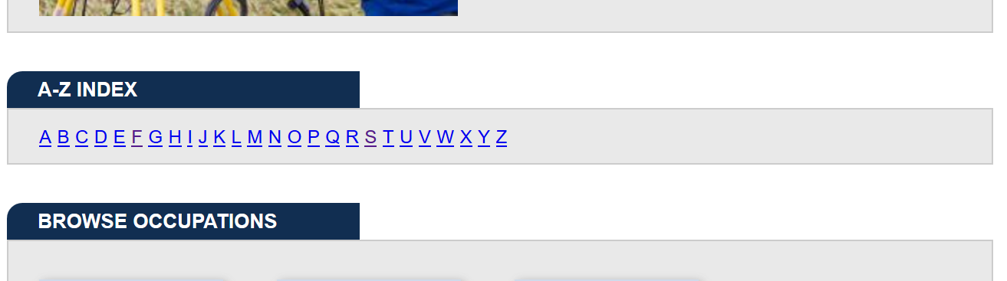
Occupation | Employment Numbers
 | 2018 | 2028 | # Change | Expected Change | Median Income
Farmers, Ranchers & other Ag Managers | 975,400 | 711 700 | -9000 | Little to No Change | $67,950
Application developers
Attorneys
Automotive Service Technician
Cashiers
Computer Programmer
Electricians
Elementary Teachers
High School Teachers
Medical Assistants
Nurses
Photographers
Physician Assistants
Plumbers
Postal Service Worker
Post-Secondary (College) Professors
Radiology Technicians
Reporters &Correspondents
Retail Sales Workers
Solar Photovoltaic Installers
Veterinary Technicians
Welders
Wildlife Biologist
Wind Turbine Service Technician
Woodworkers

